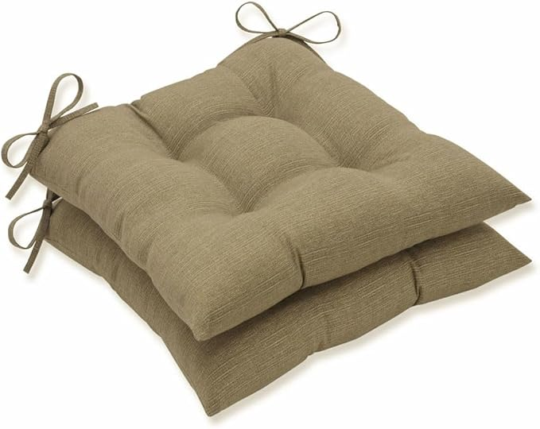

$15

Pillow Perfect Monti Chino Solid Indoor/Outdoor Wicker Patio Seat Cushion Reversible, Weather and Fade Resistant, Square Corner - 18.5" x 19", Tan, 2 Count